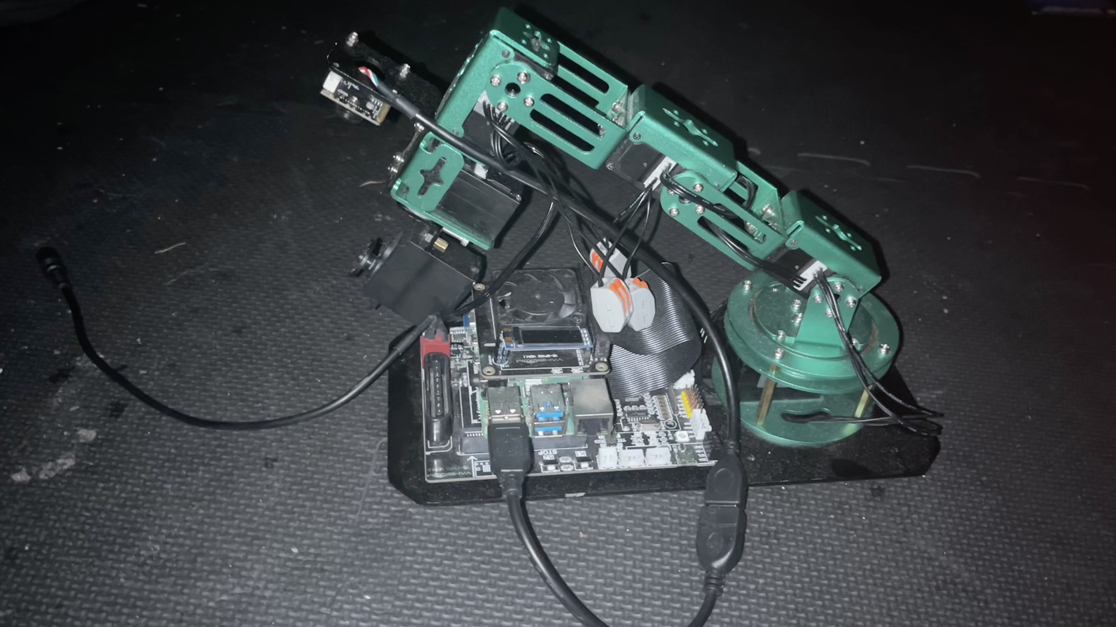

import cv2

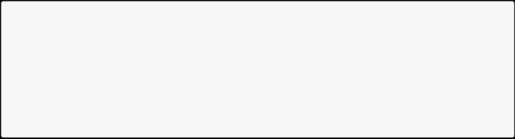

* Load the image

image = cv2.imread('example.jpg')

* Convert the image to grayscale

gray_image = cv2.cvtColor(image, cv2.COLOR_BGR2GRAY)

* Save or display the processed image cv2.imwrite('gray_example.jpg', gray_image)



awb_mode = 'fluorescent'



cv2.createTrackbar('Hue Low','myTracker',10,179,onTrack1) cv2.createTrackbar('Hue High','myTracker',30,179,onTrack2) cv2.createTrackbar('Sat Low','myTracker',100,255,onTrack3)

